**All Ordinaries Index (XAO)**

The Australian Stock Exchange (ASX) calculates and publishes a range of indices to aid clients in their investment and management decisions. Of these the most commonly quoted index is the All Ordinaries Index.

The All Ordinaries Index is a summary measure of the movement of share values that result when shares in company ownership held by individual and corporate stockholders are traded on the ASX.

In the context of the share market the All Ordinaries Index is used as an indicator of overall share market performance and of current trends. It provides a useful performance benchmark; a record of share market cycles; and an indicator of share market reactions to economic events and situations.

In a wider context the All Ordinaries index can be thought of as a reflection of the current and future health and wealth of the economy.

Graph 1 shows the All Ordinaries Index at the end of each month during the period since January 1958.  
  
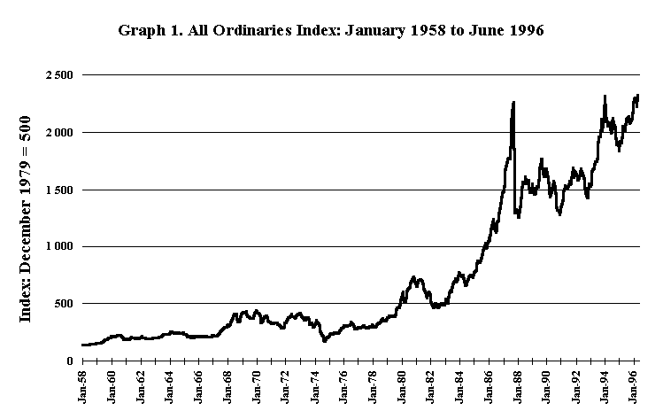

**How the All Ordinaries Index is calculated**

The All Ordinaries Index is based on the aggregate market value (AMV) of a wide selection of the companies quoted on the ASX. The market value, or market capitalisation, of any company in the All Ordinaries Index portfolio is the number of shares on issue multiplied by the current price per share in that company. The AMV of the All Ordinaries Index share portfolio is simply the sum of the market values of the companies included.

The All Ordinaries Index has been given a base value of 500.0 at the end of trading on the last trading day in December 1979. It was at this time that the ASX subsumed the operations of state-based exchanges.

Movements in the All Ordinaries Index since then have been calculated by multiplying the index by the ratio of current to past AMVs. Thus

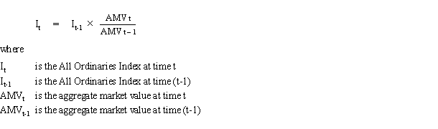

Movements in the All Ordinaries Index in the period before 1980 have been calculated using movements in the older state-based indices.

**Companies included in the index**

There are currently over 300 companies represented in the All Ordinaries Index portfolio. To be included a company must have a market value of at least 0.2% of all domestic equities quoted on the ASX and must maintain an average turnover on the ASX of at least 0.5% of its quoted shares per month. These companies currently comprise nearly 90% of total market valuation.

There are a diverse range of companies satisfying these criteria and their market values vary widely. This means that share price movements for companies with larger capitalisations have a larger effect on the All Ordinaries Index than do smaller companies.

The All Ordinaries Index portfolio is updated at the end of every month to ensure that the companies included continue to meet the criteria for inclusion. It is also updated throughout the month when there are changes in the portfolio companies including delistings, additions and capital reconstructions. Recent examples of such changes are those caused by dividend reinvestment plans of Qantas Airways and the Commonwealth Bank and the share buy back scheme of the Westpac Banking Corporation. These changes affect the number of shares on issue for each of these companies and means that the index portfolio needs to be modified to maintain index consistency.

**Update**

Established in January 1980, the **All Ordinaries** (colloquially known as the "All Ords"; also known as the **All Ordinaries Index**, AOI) is the oldest [index](https://en.wikipedia.org/wiki/Stock_index) of shares in Australia. It is made up of the share prices for 500 of the largest companies listed on the [Australian Securities Exchange](https://en.wikipedia.org/wiki/Australian_Securities_Exchange) (ASX). The [market capitalization](https://en.wikipedia.org/wiki/Market_capitalization) of the companies included in the All Ords index amounts to over 95% of the value of all shares listed on the ASX. The 3-letter exchange ticker in Australia for the All Ordinaries is "XAO".

When established, the All Ords had a base index of 500; this means that if the index is currently at 5000 points, the value of stocks in the All Ords has increased tenfold since January 1980.

On 3 April 2000, the All Ords was restructured to consist of the 500 largest companies by market capitalisation. This coincided with the introduction of new benchmark indices such as the [S&P/ASX 200](https://en.wikipedia.org/wiki/S%26P/ASX_200). The importance of the All Ords has been significantly lessened by the introduction of these new indices.

* On 31 October 2007, the index was at 6873.20, its highest value prior to the Global Financial Crisis.
* As of 22 January 2008, it had fallen to 5,222.0 points due to turmoil related to the US [2007 subprime mortgage financial crisis](https://en.wikipedia.org/wiki/2007_subprime_mortgage_financial_crisis), a 24 percent fall.
* On 6 March 2009, it was at a low of 3,111.7 points, in the wake of a worldwide drop in stock values, 54% less than the 1 November 2007 high.
* As of 14 September 2009, the index had rebounded to 4,568.5 points, representing a 46.8 percent increase from the 6 March 2009 low.
* On 5 August 2011, the index fell to 4159 points, with a 4.6% fall in one day, the biggest fall since the subprime mortgage crisis.
* On 13 February 2013, the index rose by 28.4 (0.59%) to 5,010.30, passing 5000 for the first time since the 2008 financial crisis.
* On 1 November 2017, the index rose to 6,005.50, passing 6000 points for the first time since the 2008 financial crisis.

.